Tips and Tricks for January, 2014
Submitted by Patti Karcher

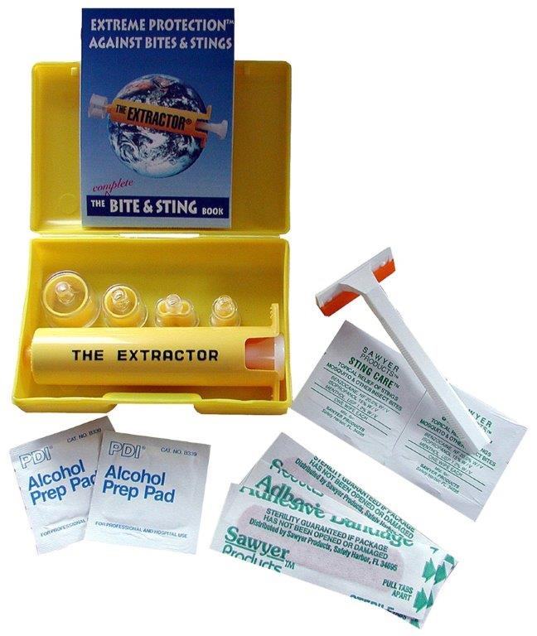
This is the snake bite kit that I mentioned November’s LFR meeting. The Co. of SD recommends this kit stating that it is the best on the market. They talk about it in their snake flyer brochure at the various staging areas. There are similar ones to this but the important key is that they must be “made” by Sawyer. I purchased mine on Amazon.com & it cost around $17.00 with shipping. Very compact and will fit in any pack – also has instructions and comes with 4 different tips for different types of bites…insects, etc. (there is also a video demonstrating how to use it on You Tube)
The snake bite kit I carry for my horse is 2 lengths of garden hose (approx.. 8” long) that are sanded smooth on each end so that they will slip into my horse’s nostrils without damaging the sensitive tissues. Dr. Katz gave the kit to me with instructions ….but very easy to make your own. I also keep a small tube of Aquaphor (or you can use Vaseline) in my pack to put on the ends to help the hose slip in smoother along with a small role of silver tape. You put the hose in the nostrils and leave them there until the swelling goes down and they will fall out by themselves – no need to worry about “removing” them yourself. I use Aquaphor as it is a natural product that has its own healing properties(recommended to me by my dermatologist)…especially if you are allergic to antibiotics. I use it on my horse’s boo-boo’s as well if he gets one while out on the trail.
Patti also suggests as women ride alone carrying a Husky razor knife with an outside clip so you can clip it inside your boot, have it to cut things in an emergency and protection.
An addition suggestion from Cyndi Denny for protection is carry a small pepper spray as well.

